fire火灾火焰目标检测
pytorch yolov5模型server接口服务及docker部署

代码dockerfile
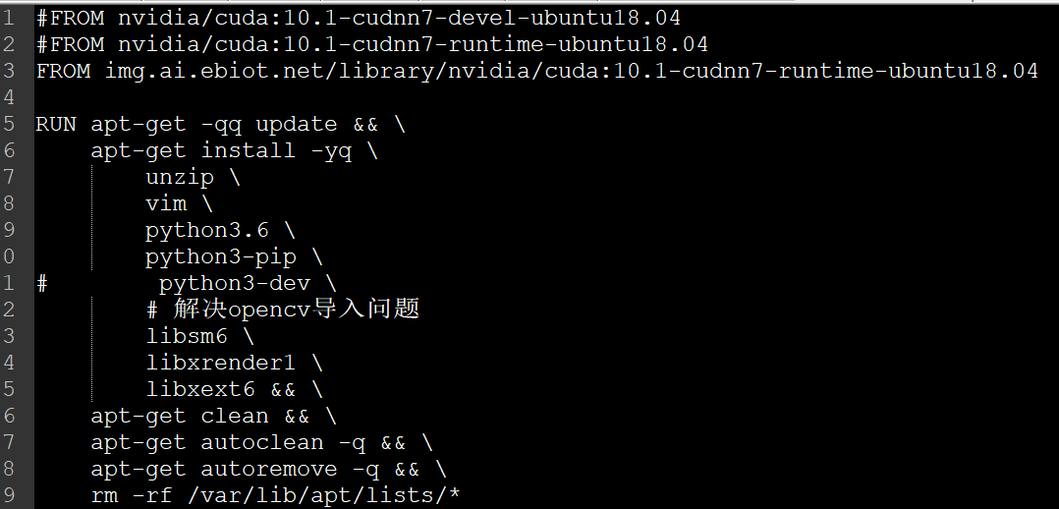
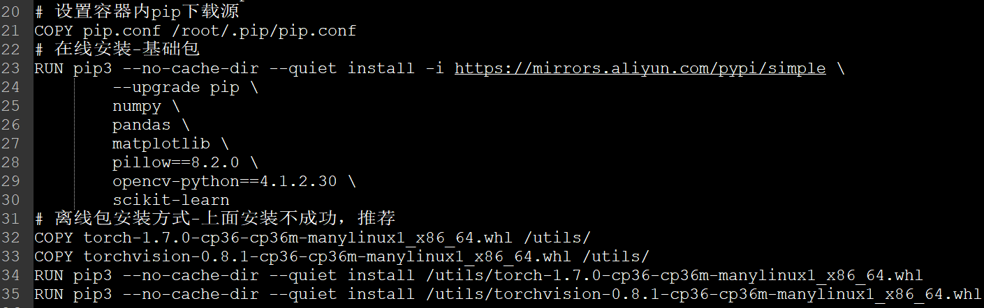
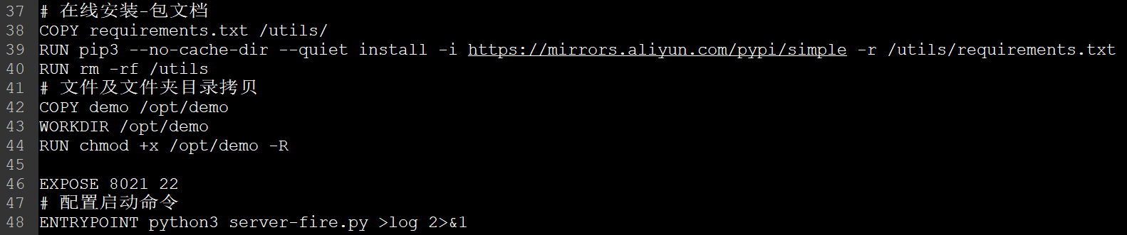

镜像fire操作步骤
/home/wk/examples_python152/fire-yolov5-serverimage
# docker build -f server2image.dockerfile -t fireyolov5-server2image-sfz:0.1 ./
# docker run -it -h "sfz" -v /home:/home -p 9730:9730 --name sfz_fireserver fireyolov5-server2image-sfz:0.1 启动并进入容器，调试时使用
# docker run -d -h "sfz" -v /home:/home -p 9730:9730 --name sfz_fireserver fireyolov5-server2image-sfz:0.1 启动后台容器，有自动启动服务时使用
# docker exec -it sfz_fireserver /bin/bash
# docker logs sfz_fireserver
# docker stop sfz_fireserver
# docker rm sfz_fireserver
上传镜像
# docker tag fireyolov5-server2image-sfz:0.1 img.ai.ebiot.net/library/fireyolov5-server2image-sfz:0.1
# docker login img.ai.ebiot.net
# docker push img.ai.ebiot.net/library/fireyolov5-server2image-sfz:0.1

用pycharm进行容器调试方法
一步一步操作用pycharm查看，可以跟踪哪一步出现错误。、
Dockerfile设置：
EXPOSE 9730 22
# 配置启动命令
#ENTRYPOINT python3 server-fire.py >log 2>&1
生成容器，不自启动服务
# docker run -it -h "sfz" -v /home:/home -p 9730:9730 -p 15522:22 --name sfz_fireserver fireyolov5-server2image-sfz:0.1 /bin/bash
# apt update
# apt install -y openssh-server
设置一个root密码，后面登陆会用到
# passwd
配置ssh
# apt-get install vim
# vi /etc/ssh/sshd_config
修改如下
Line32 #PermitRootLogin prohibit-password
添加一行PermitRootLogin yes
重启ssh服务
# service ssh restart
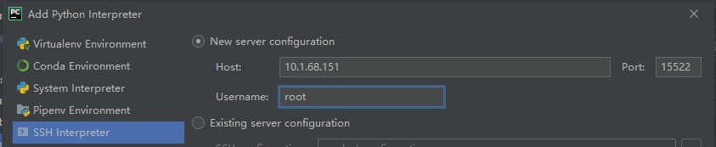
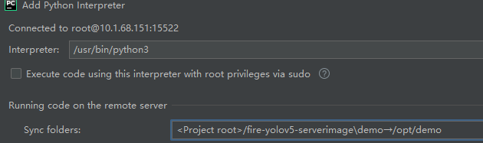
程序调试server和运行client
发现server torchvision.ops.nms运行错误自动跳出，对比是torchvision版本不同导致的。
版本torch1.7.0--torchvision0.8.1

服务不可访问调试方法
# ps -aux | grep fire 进程是否已启动
# netstat -tlpn | grep 9730 宿主机端口是否开启，有输出表名端口已开启
# lsof -i:9730 宿主机端口是否开启，有输出表名端口已开启
# ping 10.1.68.151 网络是否通达
# telnet 10.1.68.151 9730 服务端口是否可被访问
同一主机容器外启动服务
python -u /home/wk/examples_python151/fire-yolov5-serverimage/demo/server-fire.py
同一主机容器外发送client请求
python -u /home/wk/examples_python151/fire-yolov5-serverimage/demo/client-fire.py
python /home/wk/examples_python152/fire-yolov5-serverimage2/demo/client-fire.py 局域网内不同主机间测试 不能访问，因为server端口未开放

同一主机不同容器间
/opt/demo# python3 server-fire.py 容器1
/opt/demo# python3 client-fire.py 容器1指向127.0.0.1能访问
/opt/demo# python3 client-fire.py 容器2需要指向10.1.68.151才能访问

手动创建镜像进行调试方法
一步一步操作用容器生成镜像，可以跟踪哪一步出现错误。
# docker run -it -h "sfz" -v /home:/home -p 15522:22 -p 9731:9730 --name sfz_debug img.ai.ebiot.net/library/nvidia/cuda:10.1-cudnn7-runtime-ubuntu18.04
# # apt-get install -y unzip vim openssh-server python3.6 python3-pip
# # apt-get install -y libsm6 libxrender1 libxext6
# # pip3 --no-cache-dir install -i https://mirrors.aliyun.com/pypi/simple --upgrade pip setuptools
# # pip3 --no-cache-dir install -i https://mirrors.aliyun.com/pypi/simple numpy pandas matplotlib
# # pip3 --no-cache-dir install -i https://mirrors.aliyun.com/pypi/simple opencv-python==4.1.2.30 scikit-learn
# # pip3 --no-cache-dir install -i https://mirrors.aliyun.com/pypi/simple -r reqestment.txt
代码测试server-fire.py client-fire.py
# docker stop sfz_debug
容器生成镜像
# docker commit -a "sfz" -m "sfz_debug2fireimage" sfz_debug fireyolov5-conserver2image-sfz:0.1
创建带启动服务的镜像
# docker build -f server2image.dockerfile -t fireyolov5-conserver2image-sfz:0.2 ./
# docker run -d -h "sfz" -v /home:/home -p 9730:9730 --name sfz_fireserver fireyolov5-conserver2image-sfz:0.2
# docker exec -it sfz_fireserver /bin/bash
代码测试client-fire.py
# docker logs sfz_fireserver
# docker stop sfz_fireserver
# docker rm sfz_fireserver
上传镜像
# docker tag fireyolov5-conserver2image-sfz:0.2 img.ai.ebiot.net/library/fireyolov5-conserver2image-sfz:0.2
# docker login img.ai.ebiot.net
# docker push img.ai.ebiot.net/library/fireyolov5-conserver2image-sfz:0.2
在另外一台主机上拉取镜像并测试新镜像
# docker run -d -h "sfz" -v /home:/home -p 9730:9730 --name sfz_fireserver img.ai.ebiot.net/library/fireyolov5-conserver2image-sfz:0.2
# docker exec -it sfz_fireserver /bin/bash
代码测试client-fire.py
# docker stop sfz_fireserver
# docker rm sfz_fireserver

问题
1.运行dockerfile时
Command "/usr/bin/python3 -u -c "import setuptools, tokenize;__file__='/tmp/pip-build-lejif76r/pillow/setup.py';f=getattr(tokenize, 'open', open)(__file__);code=f.read().replace('\r\n', '\n');f.close();exec(compile(code, __file__, 'exec'))" install --record /tmp/pip-ur_zz9bj-record/install-record.txt --single-version-externally-managed --compile" failed with error code 1 in /tmp/pip-build-lejif76r/pillow/
Running setup.py install for Pillow: finished with status 'error'
The headers or library files could not be found for zlib,
a required dependency when compiling Pillow from source.
原因：没有指定pillow安装版本，pillow默认版本升级后用tar包源码编译安装与其他包不兼容导致。
方法：对比能兼容的版本，指定pillow版本pillow==8.2.0
；或者不安装不使用pillow包。

2.运行dockerfile时
torch==1.7.0 from https://mirrors.aliyun.com/pypi/packages/80/2a/58f8078744e0408619c63148f7a2e8e48cf007e4146b74d4bb67c56d161b/torch-1.7.0-cp36-cp36m-manylinux1_x86_64.whl#sha256=6b0c9b56cb56afe3ecbac79351d21c6f7172dffc7b7daa8c365f660541baf1a5:
Expected sha256 6b0c9b56cb56afe3ecbac79351d21c6f7172dffc7b7daa8c365f660541baf1a5
Got 360e6e312f85c959fbfba4a28aca7f3c38a900953ba8c688f06dae68993e954c
方法：多试几次；或者下载whl后再离线安装。
# 离线包安装方式-上面安装不成功，推荐
COPY torch-1.7.0-cp36-cp36m-manylinux1_x86_64.whl /utils/
COPY torchvision-0.8.1-cp36-cp36m-manylinux1_x86_64.whl /utils/
RUN pip3 --no-cache-dir --quiet install /utils/torch-1.7.0-cp36-cp36m-manylinux1_x86_64.whl
RUN pip3 --no-cache-dir --quiet install /utils/torchvision-0.8.1-cp36-cp36m-manylinux1_x86_64.whl

参考
0804_logo目标检测五pytorch yolov5模型server接口服务及docker部署
1001_docker创建tensorflow pytorch GPU容器
1301_dockerfile创建paddleGPU环境镜像自启动server服务

